**Lab Test1 *– Navyuga Toll Plaza***

**Layout Code**

<?xml version="1.0" encoding="utf-8"?>  
<android.support.constraint.ConstraintLayout xmlns:android="http://schemas.android.com/apk/res/android"  
 xmlns:app="http://schemas.android.com/apk/res-auto"  
 xmlns:tools="http://schemas.android.com/tools"  
 android:layout_width="match_parent"  
 android:layout_height="match_parent"  
 android:layout_alignWithParentIfMissing="false"  
 app:flow_horizontalAlign="center"  
 tools:context=".MainActivity">  
  
 <TextView  
 android:id="@+id/titleDescription"  
 android:layout_width="0dp"  
 android:layout_height="wrap_content"  
 android:background="#2196F3"  
 android:freezesText="false"  
 android:gravity="center"  
 android:includeFontPadding="true"  
 android:text="@string/toll_fee_collection"  
 android:textAppearance="@style/TextAppearance.AppCompat.Large"  
 android:textSize="36sp"  
 android:textStyle="bold|italic"  
 app:layout_constraintEnd_toEndOf="parent"  
 app:layout_constraintHorizontal_bias="0.492"  
 app:layout_constraintStart_toStartOf="parent"  
 app:layout_constraintTop_toTopOf="parent" />  
  
 <TextView  
 android:id="@+id/vehicleTitle"  
 android:layout_width="180dp"  
 android:layout_height="41dp"  
 android:layout_marginStart="8dp"  
 android:layout_marginLeft="8dp"  
 android:layout_marginTop="12dp"  
 android:gravity="center_horizontal"  
 android:text="@string/total_vehicles"  
 android:textAppearance="@style/TextAppearance.AppCompat.Medium"  
 android:textSize="24sp"  
 android:textStyle="bold"  
 app:layout_constraintStart_toStartOf="parent"  
 app:layout_constraintTop_toBottomOf="@+id/titleDescription" />  
  
 <TextView  
 android:id="@+id/feeTitle"  
 android:layout_width="180dp"  
 android:layout_height="41dp"  
 android:layout_marginTop="12dp"  
 android:layout_marginEnd="8dp"  
 android:layout_marginRight="8dp"  
 android:gravity="center_horizontal"  
 android:text="@string/fee_collected"  
 android:textAppearance="@style/TextAppearance.AppCompat.Medium"  
 android:textSize="24sp"  
 android:textStyle="bold"  
 app:layout_constraintEnd_toEndOf="parent"  
 app:layout_constraintTop_toBottomOf="@+id/titleDescription" />  
  
 <TextView  
 android:id="@+id/vehicleCount"  
 android:layout_width="177dp"  
 android:layout_height="159dp"  
 android:layout_marginStart="8dp"  
 android:layout_marginLeft="8dp"  
 android:gravity="center_horizontal|center_vertical"  
 android:text="@string/_0"  
 android:textColor="#0B0B0B"  
 android:textSize="100sp"  
 android:textStyle="bold"  
 app:layout_constraintStart_toStartOf="parent"  
 app:layout_constraintTop_toBottomOf="@+id/vehicleTitle" />  
  
 <TextView  
 android:id="@+id/feeCount"  
 android:layout_width="198dp"  
 android:layout_height="162dp"  
 android:layout_marginEnd="8dp"  
 android:layout_marginRight="8dp"  
 android:gravity="center_horizontal|center_vertical"  
 android:text="@string/_0"  
 android:textColor="#0B0B0B"  
 android:textSize="80sp"  
 android:textStyle="bold"  
 app:layout_constraintEnd_toEndOf="parent"  
 app:layout_constraintTop_toBottomOf="@+id/vehicleTitle" />  
  
 <Button  
 android:id="@+id/twoWheeler"  
 android:layout_width="261dp"  
 android:layout_height="62dp"  
 android:layout_marginStart="12dp"  
 android:layout_marginLeft="12dp"  
 android:layout_marginTop="8dp"  
 android:text="@string/_2_wheeler"  
 android:textSize="24sp"  
 app:layout_constraintStart_toStartOf="parent"  
 app:layout_constraintTop_toBottomOf="@+id/vehicleCount" />  
  
 <Button  
 android:id="@+id/truck"  
 android:layout_width="266dp"  
 android:layout_height="61dp"  
 android:layout_marginStart="12dp"  
 android:layout_marginLeft="12dp"  
 android:layout_marginTop="32dp"  
 android:text="@string/truck_bus"  
 android:textSize="24sp"  
 app:layout_constraintStart_toStartOf="parent"  
 app:layout_constraintTop_toBottomOf="@+id/fourWheeler" />  
  
 <Button  
 android:id="@+id/fourWheeler"  
 android:layout_width="262dp"  
 android:layout_height="55dp"  
 android:layout_marginStart="12dp"  
 android:layout_marginLeft="12dp"  
 android:layout_marginTop="32dp"  
 android:text="@string/_4_wheeler"  
 android:textSize="24sp"  
 app:layout_constraintStart_toStartOf="parent"  
 app:layout_constraintTop_toBottomOf="@+id/twoWheeler" />  
  
 <Button  
 android:id="@+id/vip"  
 android:layout_width="266dp"  
 android:layout_height="60dp"  
 android:layout_marginStart="12dp"  
 android:layout_marginLeft="12dp"  
 android:layout_marginTop="32dp"  
 android:text="@string/vip_pass"  
 android:textSize="24sp"  
 app:layout_constraintStart_toStartOf="parent"  
 app:layout_constraintTop_toBottomOf="@+id/truck" />  
  
 <Button  
 android:id="@+id/rfid"  
 android:layout_width="265dp"  
 android:layout_height="58dp"  
 android:layout_marginStart="12dp"  
 android:layout_marginLeft="12dp"  
 android:layout_marginTop="32dp"  
 android:text="@string/rfid"  
 android:textSize="24sp"  
 app:layout_constraintStart_toStartOf="parent"  
 app:layout_constraintTop_toBottomOf="@+id/vip" />  
  
 <TextView  
 android:id="@+id/count2"  
 android:layout_width="81dp"  
 android:layout_height="62dp"  
 android:layout_marginTop="8dp"  
 android:layout_marginEnd="16dp"  
 android:layout_marginRight="16dp"  
 android:gravity="center_horizontal|center_vertical"  
 android:text="@string/_0"  
 android:textAppearance="@style/TextAppearance.AppCompat.Large"  
 android:textSize="36sp"  
 android:textStyle="bold"  
 app:layout_constraintEnd_toEndOf="parent"  
 app:layout_constraintTop_toBottomOf="@+id/feeCount" />  
  
 <TextView  
 android:id="@+id/countRfid"  
 android:layout_width="80dp"  
 android:layout_height="61dp"  
 android:layout_marginTop="28dp"  
 android:layout_marginEnd="16dp"  
 android:layout_marginRight="16dp"  
 android:gravity="center_horizontal|center_vertical"  
 android:text="@string/_0"  
 android:textAppearance="@style/TextAppearance.AppCompat.Large"  
 android:textSize="36sp"  
 android:textStyle="bold"  
 app:layout_constraintEnd_toEndOf="parent"  
 app:layout_constraintTop_toBottomOf="@+id/countVip" />  
  
 <TextView  
 android:id="@+id/countVip"  
 android:layout_width="81dp"  
 android:layout_height="62dp"  
 android:layout_marginTop="32dp"  
 android:layout_marginEnd="16dp"  
 android:layout_marginRight="16dp"  
 android:gravity="center_horizontal|center_vertical"  
 android:text="@string/_0"  
 android:textAppearance="@style/TextAppearance.AppCompat.Large"  
 android:textSize="36sp"  
 android:textStyle="bold"  
 app:layout_constraintEnd_toEndOf="parent"  
 app:layout_constraintTop_toBottomOf="@+id/countTruck" />  
  
 <TextView  
 android:id="@+id/countTruck"  
 android:layout_width="81dp"  
 android:layout_height="62dp"  
 android:layout_marginTop="24dp"  
 android:layout_marginEnd="16dp"  
 android:layout_marginRight="16dp"  
 android:gravity="center_horizontal|center_vertical"  
 android:text="@string/_0"  
 android:textAppearance="@style/TextAppearance.AppCompat.Large"  
 android:textSize="36sp"  
 android:textStyle="bold"  
 app:layout_constraintEnd_toEndOf="parent"  
 app:layout_constraintTop_toBottomOf="@+id/count4" />  
  
 <TextView  
 android:id="@+id/count4"  
 android:layout_width="81dp"  
 android:layout_height="62dp"  
 android:layout_marginTop="32dp"  
 android:layout_marginEnd="16dp"  
 android:layout_marginRight="16dp"  
 android:gravity="center_horizontal|center_vertical"  
 android:text="@string/_0"  
 android:textAppearance="@style/TextAppearance.AppCompat.Large"  
 android:textSize="36sp"  
 android:textStyle="bold"  
 app:layout_constraintEnd_toEndOf="parent"  
 app:layout_constraintTop_toBottomOf="@+id/count2" />  
</android.support.constraint.ConstraintLayout>

**JAVA Code**

package com.example.navyugatollplaza;  
  
import android.support.v7.app.AppCompatActivity;  
import android.os.Bundle;  
import android.view.View;  
import android.widget.Button;  
import android.widget.TextView;  
  
  
public class MainActivity extends AppCompatActivity {  
  
 private int vehicleCount = 0;  
 private int vehicleCount2 = 0;  
 private int vehicleCount4 = 0;  
 private int vehicleCountTruck = 0;  
 private int vehicleCountVip = 0;  
 private int vehicleCountRfid = 0;  
  
 private int feeAmt = 0;  
  
 Button btn2,btn4,btnTruck,btnVip,btnRfid;  
 TextView cntVehicle,cntFee,cnt2,cnt4,cntTruck,cntVip,cntRfid;  
  
  
 @Override  
 protected void onCreate(Bundle savedInstanceState) {  
 super.onCreate(savedInstanceState);  
 setContentView(R.layout.*activity_main*);  
  
 btn2 = (Button) findViewById(R.id.*twoWheeler*);  
 btn4 = (Button) findViewById(R.id.*fourWheeler*);  
 btnTruck = (Button) findViewById(R.id.*truck*);  
 btnVip = (Button) findViewById(R.id.*vip*);  
 btnRfid = (Button) findViewById(R.id.*rfid*);  
  
 cntVehicle = (TextView) findViewById(R.id.*vehicleCount*);  
 cntFee = (TextView) findViewById(R.id.*feeCount*);  
 cnt2 = (TextView) findViewById(R.id.*count2*);  
 cnt4 = (TextView) findViewById(R.id.*count4*);  
 cntTruck = (TextView) findViewById(R.id.*countTruck*);  
 cntVip = (TextView) findViewById(R.id.*countVip*);  
 cntRfid = (TextView) findViewById(R.id.*countRfid*);  
  
 btn2.setOnClickListener(new View.OnClickListener(){  
 @Override  
 public void onClick(View v) {  
 vehicleCount++;  
 cntVehicle.setText(Integer.*toString*(vehicleCount));  
 vehicleCount2++;  
 cnt2.setText(Integer.*toString*(vehicleCount2));  
 feeAmt+=100;  
 cntFee.setText(Integer.*toString*(feeAmt));  
 }  
 });  
  
 btn4.setOnClickListener(new View.OnClickListener(){  
 @Override  
 public void onClick(View v) {  
 vehicleCount++;  
 cntVehicle.setText(Integer.*toString*(vehicleCount));  
 vehicleCount4++;  
 cnt4.setText(Integer.*toString*(vehicleCount4));  
 feeAmt+=200;  
 cntFee.setText(Integer.*toString*(feeAmt));  
 }  
 });  
  
 btnTruck.setOnClickListener(new View.OnClickListener(){  
 @Override  
 public void onClick(View v) {  
 vehicleCount++;  
 cntVehicle.setText(Integer.*toString*(vehicleCount));  
 vehicleCountTruck++;  
 cntTruck.setText(Integer.*toString*(vehicleCountTruck));  
 feeAmt+=400;  
 cntFee.setText(Integer.*toString*(feeAmt));  
 }  
 });  
  
 btnVip.setOnClickListener(new View.OnClickListener(){  
 @Override  
 public void onClick(View v) {  
 vehicleCount++;  
 cntVehicle.setText(Integer.*toString*(vehicleCount));  
 vehicleCountVip++;  
 cntVip.setText(Integer.*toString*(vehicleCountVip));  
 feeAmt+=0;  
 cntFee.setText(Integer.*toString*(feeAmt));  
 }  
 });  
  
 btnRfid.setOnClickListener(new View.OnClickListener(){  
 @Override  
 public void onClick(View v) {  
 vehicleCount++;  
 cntVehicle.setText(Integer.*toString*(vehicleCount));  
 vehicleCountRfid++;  
 cntRfid.setText(Integer.*toString*(vehicleCountRfid));  
 feeAmt+=50;  
 cntFee.setText(Integer.*toString*(feeAmt));  
 }  
 });  
  
 }  
}

**Manifest File**

<?xml version="1.0" encoding="utf-8"?>  
<manifest xmlns:android="http://schemas.android.com/apk/res/android"  
 package="com.example.navyugatollplaza">  
  
 <application  
 android:allowBackup="true"  
 android:icon="@mipmap/ic_launcher"  
 android:label="@string/app_name"  
 android:roundIcon="@mipmap/ic_launcher_round"  
 android:supportsRtl="true"  
 android:theme="@style/Theme.NavyugaTollPlaza">  
 <activity android:name=".MainActivity">  
 <intent-filter>  
 <action android:name="android.intent.action.MAIN" />  
  
 <category android:name="android.intent.category.LAUNCHER" />  
 </intent-filter>  
 </activity>  
 </application>  
  
</manifest>

**Output Screenshots**

1. **Initial Screen**

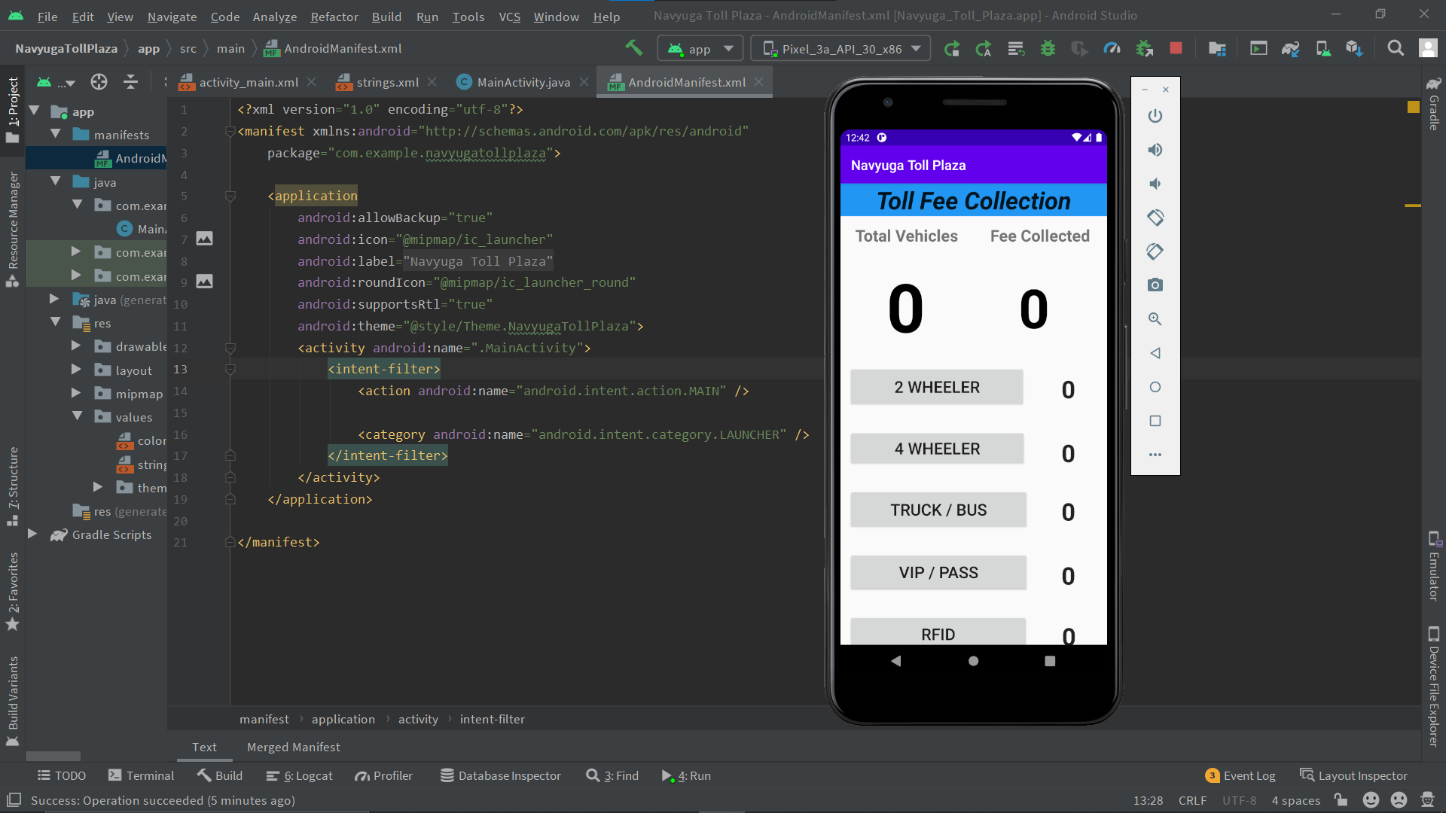

1. **Putting Data and clicking various buttons**

